
LGICT ADVISORY
04/27/2026 | ADVISORY NO. 2026-0020
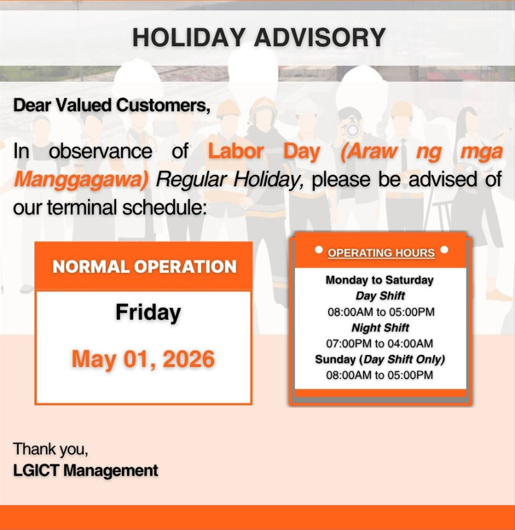

To support the continuous requirements of the logistics industry and the diverse manufacturing and warehousing companies located in the Laguna and Batangas area, here is the list of LGICT Services that can support your operations:

1. Off-Dock Customs Facility (OCF) Transfer – MICT to LGICT
2. Import Customs Cleared Transfer – MICT to LGICT
3. Export Drop-Off Service – LGICT to MICT
4. Container & Project Cargo Yard Storage Facility
5. Reefer Live Plug-Ins
6. Open Yard Stripping & Stuffing
7. Container Freight Station Services:
a. Import and export consolidation
b. Cross-docking operations – Stripping & Stuffing
c. Loose Cargo Storage
8. Trucking Services
9. Container Yard Management and Equipment Leasing
10. ISO Tank MnR and Pre-heating
11. Weighing Facility
12. Freight/Cargo Train Operations – MICT to LGICT / LGICT to MICT (pending development)

Meantime, here is the list of LGICT accredited shipping lines. For any booking requirements and empty container return requests, kindly reach out to your respective shipping lines.

1. CMA-CGM, APL, CNC
2. COSCO
3. EVERGREEN
4. HYUNDAI
5. MAERSK, MCC, SEALAND
6. ONE

Should you have any questions and or inquiries, please do not hesitate to contact us.

For gate pass request:
Send your email to billing@lgict.ictsi.com every Monday to Saturday (8am - 5pm)

LGICT Commercial:
Jhoemari Yumul jyumul@lgict.ictsi.com 0928 551 0118
Ivan Limuco ilimuco@lgict.ictsi.com 0917 539 1309
Victor Ilin vilin@lgict.ictsi.com 0997 6043429

Customer Care:
csg@lgict.ictsi.com 0947 993 3673

Operations Support:
opdocs@lgict.ictsi.com 0947992 7160
yardops@lgict.ictsi.com 0919 060 3239
exe@lgict.ictsi.com 0968 860 7583
ocfsupport@lgict.ictsi.com 0961 334 7064

For more featured services and updates please join our VIBER community and follow us on LinkedIn!!

Laguna Gateway Inland Container Terminal, Inc.
Address: LGICT Compound, Old National Highway, Brgy. San Cristobal, Calamba City 4027, Laguna
Tel #: (049) 559-4434
Website: www.lgict.com.ph

